Cyber Security Incident Response Plan Framework

Version:
5

Author/Owner:
Information Security Manager/Chief Information Officer

Contents
Contents 2
Document version history 3
1. Purpose 4
2. Scope 4
2.1. In scope 4
2.2. Out of scope 4
2.3. Incident Management Lifecycle 5
3. Response 6
3.1. Preparation 6
3.2. Detection and Analysis 8
3.1. Incident Response–- Containment, Eradication & Recovery 13
3.2. Post Incident Activity / Lessons Learned 15
4. RESPONSIBILITY 16
5. DEFINITIONS AND ACRONYMS 17
6. DOCUMENTATION 18
7. REFERENCES 18
APPENDIX A: CYBER SECURITY INCIDENT SEVERITY MATRIX 20
APPENDIX B: EMP CLASSIFICATION MATRIX: SECURITY IMPACTS 22
APPENDIX C: INCIDENT COMMUNICATIONS AND NOTIFICATION PLAN 23
Introduction 23
Cyber Security Incident Communications – Major or above rating 23
Cyber Security Incident Communications – Limited or lower rating 24
External Notifications and Communications 25
APPENDIX D: DEFINITIONS AND INCIDENT CATEGORIES 27
Key Definitions 27
APPENDIX E: INCIDENT LOG TEMPLATE 29
QUICK REFERENCE WORKFLOW – CYBER SECURITY INCIDENT RESPONSE 33

Document version history

Version | Changes made to document
3 | Updates and change to new template.
4 | Inclusion of OT
5 | Clean up and removal of former IT Operations Manager Post OT exercise

Purpose
The purpose of this document is to provide Wannon Water with a framework for ensuring a standardised, repeatable method for detecting and managing cyber security incidents. A cyber security incident is any event that threatens the security, confidentiality, integrity or availability of the organisation’s information and operational assets. The framework and processes set out in this document align to Wannon Water’s Cyber Resilience Strategy, the business Emergency Management Plan (EMP), and the best practice standards for cyber security incident management (NIST 800-61 and ISO-27035).
This Framework document should be read in conjunction with the individual cyber incident management plan scenario playbooks (Playbooks) to ensure a robust and holistic approach is taken to managing cyber incidents. The individual Playbooks provide the Wannon Water Information Security Incident Response Team (ISIRT) with step by step instructions for each of the following incident types:
- Data Breach
- Third Party Data Breach
- Ransomware
- Phishing
- System Compromise
- Denial of Service (DOS)

Having an effective incident reporting and investigation framework enables Wannon Water to meet legislative obligations, ensure lessons are learned from incidents occurring, and help identify controls to prevent reoccurrence. Wannon Water is exposed to numerous incidents of varying type and severity levels ranging from incidents that can be managed on-site locally (e.g. an isolated security breach) to wide scale incidents involving service disruption across multiple systems.

Scope

In scope
The Wannon Water Cyber Security Incident Management Framework encompasses the identification and management of incidents:
- in the Information Technology (IT) domain;
- in the Operational Technology (OT) domain;
- that are defined in the EMP and have as a contributing root cause a cyber security event. For example, the compromise of an OT SCADA system by software infection which ultimately impacts water flow or water quality would involve the instigation of cyber incident management processes (the Playbook linked to System Compromise) under this framework, as well as the instigation of incident management processes related to the non-cyber impacts of the compromise (as per the EMP).

Out of scope
The following items are considered out of scope for the application of this framework:
- The management and treatment of Incidents that are not related to cyber security factors and do not have cyber security issues as a contributing cause of any incident (i.e. no impact to systems, technology or data and no causes related to the materialisation of cyber security threats).
- Business continuity or business response beyond technical IT and OT controls.

Incident Management Lifecycle
Cyber Security Incidents are managed in accordance with the guidelines set out in the NIST 800-61 Incident Response Lifecycle and accord to four main phases. These phases represent the application of best practice incident management processes:
- Preparation
- Detection & Analysis
- Containment, Eradication & Recovery
- Post-Incident Activity
Figure 1 shows a visual representation of the 4 phases.
This document examines all 4 phases from a holistic standpoint, whilst the individual Playbooks (representing incident scenarios) focus on the fine details of phases 2 and 3. Where there is variation from what is described in this document for phases 1 and 4, this is detailed in the individual Playbooks.

Figure 1 – NIST 800-61 Incident Response Lifecycle
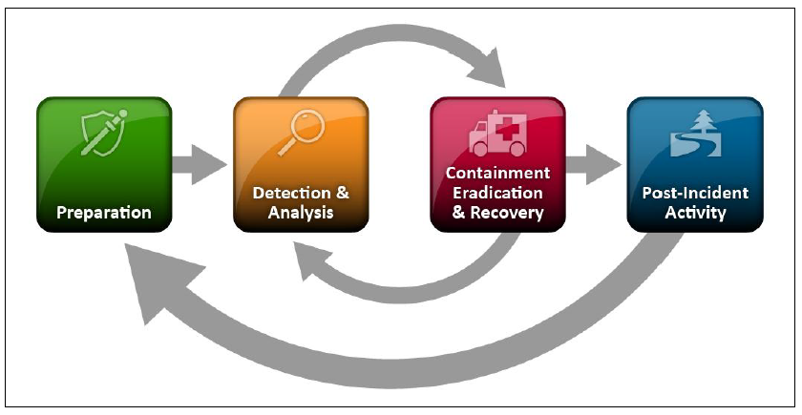

The EMP sets out 3 levels of severity for the classification of incidents – in order of increasing severity: (i) Operational, (ii) Enhanced Operational, and (iii) Incident Management Team (IMT). Each level also has increasing levels of incident complexity, employee involvement, resourcing, internal liaison and external liaison.

Impacts from a cyber security incident are commonly graded on a severity scale with 5 levels:

- None/negligible;
- Minor;
- Moderate;
- High;
- Very High.

Refer to Appendix A for a detailed description of the cyber security incident impact types against these severity levels.

A formal declaration of a cyber security incident could ultimately lead to the declaration of an Emergency, as defined in the EMP (p14). In this instance, procedures for cyber security incident remediation and Emergency remediation may be applied conjunctionally to aid in incident recovery.

Response
This document sets out how to deal with cyber security incidents as per the 4 phases defined in the previous section:
- Preparation
- Detection & Analysis
- Containment, Eradication & Recovery
- Post-Incident Activity
Each phase will be detailed in this section. The information hereafter should be considered in conjunction with the Playbook relevant to the incident scenario.

Preparation

Figure 2 – Preparation phase of the Incident Response Lifecycle
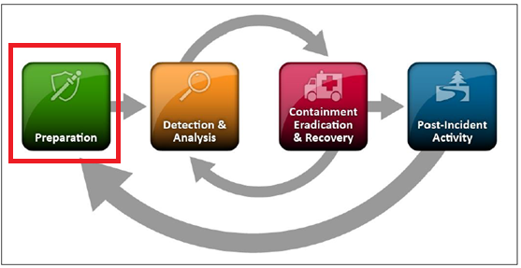
Overarching responsibility for implementing the incident response framework for Wannon Water falls to the Information Security Incident Response Team. The ISIRT is an organisational function that covers the process for information security incidents and is focused mainly on IT security incidents. At a bare minimum, the members of the ISIRT accord with the following organisational roles:
- Information Security Manager
- IT Operations Manager
- Chief Information Officer
- Manager Risk & Resilience
- Enterprise Network Technical Lead

Additional members may be recruited into the ISIRT from time to time as needed to meet the requirements of incidents as they occur.

Incident response methodologies typically emphasise preparation—not only establishing an incident response capability so that the organization is ready to respond to incidents, but also preventing incidents by ensuring that systems, networks, and applications are sufficiently secure. Although the ISIRT is not wholly responsible for incident prevention, its role is fundamental to the success of incident response programs.

Additional measures to ensure adequate preparation for the occurrence of a cyber security incident are listed as follows:

- Ensure an updated and reviewed contact matrix is maintained, detailing key contacts both within and external to Wannon Water. Information to include email addresses, phone numbers, and if applicable public encryption keys. Refer also to the Core Services Map documents for critical system ownership and information;
- On-call information and escalation criteria;
- Established incident management and risk reporting system, supported by issue tracking and problem management functionality (e.g. IRIS or equivalent risk management system);
- Secure storage systems for securing incident history, forensic evidence etc.;
- 24 hour/365 days monitoring of key security variables (logging and event management) via a dedicated Security Operations Centre (SOC);
- Cyber security education, training and awareness programs (supported by, for example, phishing awareness campaigns);
- Vulnerability management programs to detect and mitigate system security vulnerabilities;
- In-house or externally available digital forensic capability, including evidence gathering resources such as chain of custody forms, digital cameras, audio recorders, evidence storage bags etc.;
- Configuration Management Database (CMDB) to include configuration items for all critical systems, Operating Systems (OSs), applications, network devices, and secure configuration baseline for critical systems;
- Network diagrams and listings of all critical digital assets (e.g. servers ,databases and OT devices);
- Documentation for OSs, applications and network security appliances (e.g. firewalls and intrusion detection systems);
- Ready access to clean images of Standard Operating Environment (SOE) OS and key applications, to aid in restoration and recovery. These artefacts should be a part of a data and system backup management plan.
- Adherence to a published schedule for testing the Cyber Security Incident Response Plan and Playbooks via simulation or tabletop exercises. These will be used to assess the adequacy and effectiveness of the Framework and should feed into the Lessons Learned aspect of Phase 4.
- Configuration documentation, where available, for OT devices.

Detection and Analysis

Figure 3 – Detection & Analysis phase of the Incident Response Lifecycle

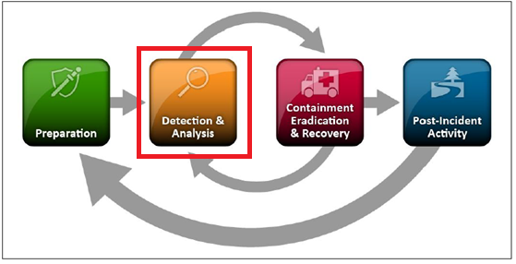
Cyber security incidents are highly variable in nature, so capturing common characteristics for all of them is not possible. An incident can evolve from a cyber security event that does not conform to expected behaviour or parameters. This type of event may or may not lead to the formal identification of an incident (See Appendix D). Once a particular incident has been identified (for example, Ransomware), the appropriate Playbook should be consulted and read in conjunction with this document. Following detection and analysis, incident triage and classification will need to be applied.
Detection: The detection of a cyber security incident can come from many sources. The most common for Wannon Water would include:
  - Security Operations Centre alerting/notification
  - End user/employee
  - Wannon Water Customer
  - Helpdesk
  - Vendor
  - Vulnerability assessment
  - Audit

Analysis: At the point of notification, it is not certain that the alert will result in a formal incident being identified. It is the task of the ISIRT to determine if an incident is to be declared by applying a triage and classifying the incident. Triage will determine the incident severity, and the classification will determine what Playbook/s should be consulted for progressing incident remediation. Considerations for the ISIRT include:
- Assessment of risk
- Determine scope of impact – IT and / or OT?
- Is company proprietary data involved?
- Is Personally Identifiable Information (PII) involved?
- Interview the notification source/s
- Identification of affected systems and information assets, including the BIL ratings of impacted information.
- Data collation
- Criticality of the systems involved
- Where OT systems are involved, the businesses capacity to continue operations with those systems degraded or unavailable
- During the Triage and Classification process, the ISIRT should convene and initiate a conference call with all concerned stakeholders. Required and optional attendees are listed in Table 1.

Table 1 – Conference Call Attendees
Function | Role | Current Contact | Contact number
ISIRT | Information Security Manager | Craig Roberts | 0439900269
ISIRT | IT Operations Co-ordinator | Darren Ladhams | 0428517663
ISIRT | Enterprise Network Lead | Ash Advincula | 03 55656614, 0418123357
ISIRT / IMT | Manager Risk & Resilience | Brent Smith | 03 55656712, 0475286790
ISIRT / IMT | Chief Information Officer | Andrew Dilley | 03 55656638, 0408647600
Kinetic IT SOC * | Security Operations Centre – Main line | Susan Hutchins / Tony Campbell | 08 92380011  0409474080

Function | Role |  | Current Contact |  | Contact number
DGS CIRS* |  | Victorian Cyber Incident Response Service |  | - | 1300 278 842  Cybersecurity@dpc.vic.gov.au
OVIC * |  | Office of the Victorian Information Commissioner |  | - | 03 86841658  incidents@ovic.vic.gov.au
DEECA* |  | Water Duty Officer |  | - | 0436 693 498  water.emergency@delwp.vic.gov.au
* Optional attendees (dependent on incident type).
Highlighted rows reflect conference call attendees if escalation is indicated as per Tables 2 and 3
Once all required members have been added into the conference call, the ISIRT should ensure that the meeting events are carefully recorded in meeting minutes or voice recorded. This information will be used to help complete an Incident Report or Incident Log if an incident is subsequently declared. An Incident Log template is included in Appendix E.
Although the primary reason for gathering evidence during an incident is to resolve the incident, it may also be needed for legal proceedings. In such cases, it is important to clearly document how all evidence, including compromised systems, has been preserved. Evidence should be collected according to procedures that meet all applicable laws and regulations which have been developed from previous discussions with legal staff and appropriate law enforcement agencies. This is to ensure that any evidence is admissible in court. In addition, evidence should be accounted for at all times: whenever evidence is transferred from person to person, chain of custody forms should detail the transfer and include each party’s signed authorisation. A detailed log should therefore be kept for all evidence.

Applying a triage will help to determine the incident severity and classification. Given that the full impact and root cause of the incident may not be immediately evident, investigations should continue until this is established. Determining whether a particular event is actually an incident is sometimes a matter of judgement. It may be necessary to collaborate with other technical and information security personnel to make a decision. The key objectives of the meeting for the ISIRT and other conference call attendees should be to:
  - Perform an incident analysis based on the evidence provided and the source data. Consider the method of detection and any people involved in the escalation to the ISIRT;
  - Triage: Complete an evaluation of the incident severity based on the incident characteristics identified and the escalation criteria as defined in Appendix A. This evaluation will assist in grading incident severity on the scale of 5 levels from ‘None/Negligible’ to ‘Very High’. If an incident has characteristics/symptoms that span multiple rows of the table, the incident severity will be determined by the greatest severity rating of all row items. For example, looking at two line-items in the Appendix A matrix, if a security incident has resulted in a significant impact to production (high severity rating) which also affects critical OT systems (very high severity rating), then the incident severity determined by triage should be ‘Very High’. Appendix B contains an extract of the EMP to be used for determining if ‘Enhanced Operational’ or ‘IMT’ levels of incident management need to be applied for IT security related threats as per the requirements of the Emergency Management Plan;
  - Classification: Consult the relevant Playbook for the incident type identified. For example, dealing with the disclosure of login credentials to unauthorised external parties resulting from a targeted email scam, refer to the ‘Phishing’ playbook. Apply any steps from the Playbook for the ongoing analysis and remediation of the incident;
  - Continue triage and include (if necessary) relevant managers/team leads as impacted areas are identified. Refer to details in the Core Service Map Documents;
  - Identify the primary root cause, data collection and forensics requirements;
  - Identify senior stakeholders and commence notification processes as per the Communications Plan (see Appendix C). Incidents classified as ‘High’ or ‘Very High’ will have communications handled as described in Table C1, and ‘Medium’ or lower handled as described in Table C2.
  - Ensure that all decisions and analysis are recorded in the Incident Log.

For example, in Table 2 below, the determination of the cyber security incident severity is made in step 1 by the ISIRT (or individual team members of the ISIRT) by looking at the impact type and severity ratings shown in Appendix A. Up to this point in time the incident severity has not been confirmed. As such, all incidents should be treated as potentially serious until the triage is complete (requiring ISIRT involvement from the point where the incident report is received).
A second decision is then required (step 2) to determine if the EMP needs to be invoked. In this case, refer to Appendix B. The table in Appendix B will assist in determining if the EMP provisions should be utilised (i.e. if the table indicates that the EMP incident classification level is ‘Enhanced Operational’ or ‘IMT’). Step 3 follows the decision points around whether to engage external parties (by referring to Table 3), and step 4 involves implementing the appropriate Playbook/s.

Table 2–- Triage Evaluation and Escalation Matrix
Step | Stage | Resource | Reference | Team Responsible
1 | Triage: Assess Security Incident severity | Incident Severity Rating Matrix | Appendix A | ISIRT or ISIRT team members
2 | Triage: Assess need to invoke EMP | EMP ratings for cyber security | Appendix B | ISIRT
3 | Escalation–- Assess need to engage external parties | Third party escalation decision matrix | Table 3 | ISIRT
4 | Classification -Implement Playbook | Playbooks IRP1-6 | Playbooks | ISIRT + External Parties if applicable

To put this in context, refer to Figure 4, which is an extract of the Process Workflow on page 3. For the Detection and Analysis phase of the Incident Response Lifecycle, the four steps in Table 2 have been superimposed onto this diagram for clarity.
Figure 4 – Detection and Analysis Phase: Escalation and Engagement
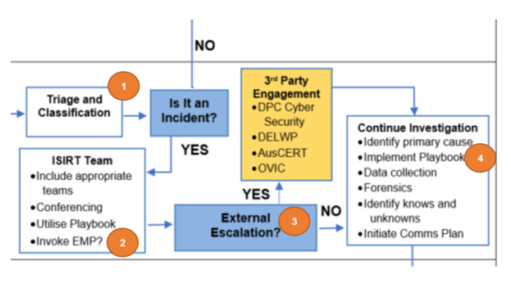
The criteria for which external agencies to engage and under what circumstances (step 3), can be found in Table 3. This sets out the minimum rating for (a) cyber security incident/s under this framework; and (b) the EMP, needed to engage key external agencies under defined circumstances. For example, when forensic analysis or assistance is required that is not found in-house at Wannon Water, the DPCV cyber security team should be engaged when the minimum cyber incident severity rating is ‘Moderate’ or higher. Under the EMP requirements, the DPCV cyber security team should be engaged when the classification is ‘Enhanced Operational’ or higher. Examine Appendices A and B to determine what the escalation requirements are. In the event the decision to escalate comes from one of the two frameworks, but not both, the escalation should proceed.

Table 3 – Third Party Escalation Decision Matrix
External  Organisation | Criteria | Minimum Requirements to Engage
External  Organisation | Criteria | Cyber Security Incident Rating – Appendix A | EMP Classification – Appendix B
CIRS Cyber Security | Cyber Security Incident involving specialist forensic or technical capability not found in-house. We are obliged to report cyber incidents of BIL 2 impact or higher to CIRS | Limited | Enhanced Operational
DEECA | Credible threat or impact to ICT systems with potential regional consequences. DEECA requests notification of any cyber incident | Limited | IMT
OVIC | Cyber Security incident involving a data breach with the loss of Personal Information subject to the Privacy Act or a breach of an Information Asset with a BIL or 2 or higher | Limited | IMT

Incident Response–- Containment, Eradication & Recovery

Figure 5 – Containment, Eradication & Recovery phase of the Incident Response Lifecycle
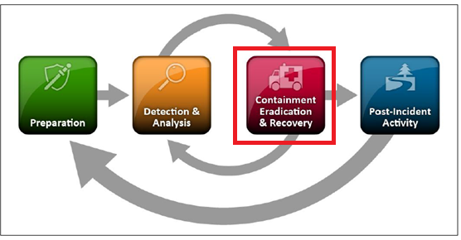

Containment: Containment is important to ensure that the incident doesn’t overwhelm Wannon Water’s resources or produce additional ongoing impacts to systems or information assets. Containment provides time for developing a tailored remediation strategy. An essential part of containment is decision-making (e.g. whether to shut down a system, disconnect it from a network, disable certain functions etc.). Such decisions are much easier to make if there are predetermined strategies and procedures for containing the incident. Wannon Water manages this risk through the use of detailed Playbook instructions to deal with containment.
Containment strategies vary based on the type of incident. For example, the strategy for containing an email-borne malware infection is quite different from that of a network-based dDoS attack. Refer to the correct Playbook for full instructions.

Eradication: After an incident has been contained, eradication may be necessary to eliminate incident symptoms, such as deleting malware, disabling breached user accounts, as well as identifying and mitigating all vulnerabilities that were exploited. During eradication, it is important to identify all affected servers and endpoint devices so that they can be remediated. For some incidents, eradication is either not necessary or is performed during recovery. Follow the Playbook instructions for effective eradication steps.

Recovery: Implement the Playbook requirements to assist with effective incident recovery. Examples may include administrators restoring systems to normal operation and confirming that the systems are functioning normally. Recovery may involve such actions as restoring systems from clean backups, rebuilding systems from scratch, replacing compromised files with clean versions, installing patches, changing passwords, disabling any vulnerable services or components, and tightening network perimeter security (e.g. firewall rulesets and boundary router access control lists). Higher levels of system logging, network monitoring or the deployment of additional security controls are also often part of the recovery process. Once a resource is successfully attacked, it is often attacked again, so full recovery should be robust and completed in conjunction with the Lessons Learned section below.

In summary, the ‘Containment, Eradication and Recovery’ phase is a critical part of the Incident Response Lifecycle, the main objectives of which are as follows:
- Confirm the criticality of data and systems effected (referring to the relevant Wannon Water Incident Response Playbook), and assign prioritised remediation tasks and follow-up timeframes so that the relevant support teams can contain the incident;
- Remove all signs, symptoms and causes of the incident from affected systems to ensure the problem is eradicated;
- Recover and restore systems as necessary to resolve the incident;
- Provide updates to identified stakeholders in line with the Communications Plan (see Appendix C), notify any affected users of the incident remediation, and if required, notify the regulatory authorities (dependent on the nature of the incident).

Incident Closure: Close out all linked service tickets updating details as necessary and capturing process remediation requirements as identified. Send incident closure email to relevant staff as identified on the Communications Plan.

Post Incident Activity / Lessons Learned

Figure 6 – Post Incident Activity phase of the Incident Response Lifecycle
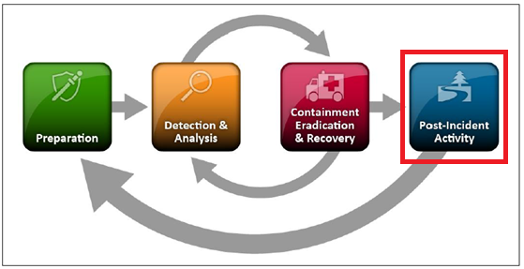

Once the incident has been closed, post incident activities should be conducted and should incorporate a ‘Lessons Learned’ aspect. A post-incident review should cover off points to enquire whether the incident was managed effectively with a view towards incorporating any potential improvements into the management of future incidents. These should include:
- Confirmation that the incident has been resolved and the Incident Log is reviewed for closure;
- Initial mitigation strategies review–- Was the incident contained? Was process followed, and were the right people involved?
- Communications review – were the correct people notified as per the Communications Plan and were updates timely and accurate? Were all incident activities recorded appropriately?
- Were any outstanding or unresolved issues or vulnerabilities captured in the problem management system or risk management system (IRIS)? This will be required for mitigation of like impacts during any future incidents.
- Review remediation activities – did the restoration activity work as expected? Was required system documentation available and accurate? Are any updates required for the incident response documents and framework? Update process, framework and Playbook documentation accordingly in line with the lessons learned.
An effective Incident Response Framework should involve testing the Plan and Playbooks on a regular basis. This can take the form of exercises or simulations of varying complexity (from a simple tabletop simulation right up to a full test of all aspects of incident management just as if a real incident had occurred). The schedule for testing of the plans should be published and adhered to, with the outcomes of the testing feeding into the Lessons Learned component of incident management.

RESPONSIBILITY
While every incident may be different, the roles and responsibilities for key personnel are as described in the following RACI Charts (Tables 4a and 4b). The initial incident triage will determine if the Victorian Department of Premier and the Cabinet (DPCV) (or other external party) is required to be engaged to facilitate incident containment and remediation. This determination will be performed by the Information Security Incident Response Team (ISIRT).

Table 4a sets out the roles and responsibilities where it has been determined by the ISIRT that no DPCV Cyber Security Unit (CSU) response is required, and Table 4b where the team has decided that DPCV CSU needs to be engaged to effect incident remediation. The decision to engage or not to engage the CSU should accord with the criteria set out in Table 3 on page 11 but the final decision is entirely at the discretion of the ISIRT and may be dependent on factors such as the requirement for additional or specialist resources.

Table 4a – Cyber Incident Roles and Responsibilities: No DPCV CSU involvement
 | Information Security Manager | CIRS Response Team | Wannon Water Technical Teams | Incident Management Team (ISIRT) | Subject Matter Expert/s
Analysis, Triage & Classification | A/I | I | R | R | C
Containment | A/I | - | R | R | C
Eradication & Recovery | A/I | - | R | R | C
Closure & Notification | A/I | I | R | R | C

Table 4b – Cyber Incident Roles and Responsibilities: DPCV CSU involvement
 | Information Security Manager | CIRS Response Team | Wannon Water Technical Teams | Incident Management Team (ISIRT) | Subject Matter Expert/s
Analysis, Triage & Classification | A/I | C | R | R | C
Containment | A/I | R | R | C | C
Eradication & Recovery | A/I | R | R | C | C
Closure & Notification | A/I | I | R | R | C
R – Responsible, A-Accountable, C-Consulted, I-Informed

‘Wannon Water Technical Teams’ includes any team or function that manages or has responsibility for information resources, technology, platforms or expertise related to the nature of the incident under assessment.

DEFINITIONS AND ACRONYMS
Availability–- The information security concept that applies to ensuring that information and information systems are available when needed.

CMDB – Configuration Management Database

Confidentiality – The information security concept that applies to preventing unauthorised access to protected and sensitive information assets.

Denial of Service (DOS) or Distributed Denial of Service (DDOS) Attack – An attack intended to overwhelm or overload a system or host in order to cause disruption and service outage. A DDOS attack is typically characterised by having a large number of remote compromised machines under a command and control server operated by the threat agent.

DPC – Department of Premier and the Cabinet

EMP – The Wannon Water Emergency Management Plan.

Event – A cyber security event is any observable or logged occurrence in a system or network. See Appendix D

ICS – Industrial Control Systems

Incident–- A cyber security incident is a violation or imminent threat of violation of security policies, acceptable use policies, or standard security practices resulting in impacts and/or loss. See Appendix D

Integrity – The information security concept that applies to ensuring that information is accurate, complete and un-modified by unauthorised parties over the entire lifecycle of the data.

ISIRT – Information Security Incident Response Team

IT – Information Technology

Malware – Malicious Software

OT – Operational Technology. Systems such as ICS and SCADA used in industrial process control.

Phishing – A campaign of fraudulent emails using deception to redirect recipients to a malicious infected web host, and/or to harvest login credentials to systems.

PII – Personally Identifiable Information

Playbook – a step by step procedure for dealing with the management and treatment of a security incident. A Cyber Security Incident Response Playbook deals predominantly with the ‘Detection and Analysis’ and ‘Containment, Eradiation and Recovery’ phases of the incident response lifecycle (phases 2 and 3).

RACI – an acronym used in responsibility matrices – Responsible, Accountable, Consulted & Informed

Ransomware – Ransomware is a form of malicious software (malware) that encrypts a victim’s files. The victim is then encouraged to pay a ransom to have the files decrypted and restored. The perpetrators of the ransomware attack may or may not provide the decryption key upon payment.

SOC – Security Operations Centre

Spear-phishing – As per Phishing but with one specific organisation or user being targeted by the phishing campaign.

DOCUMENTATION

- Core Services Map Documents
- Incident Response Playbooks

REFERENCES
- Emergency Management Plan
- Hazard Reporting Procedure
- NIST 800-61–- Computer Security Incident Handling Guide
- ISO 27035:2016–- Information Security Incident Management
- Emergency Management Act 2013
- Emergency Management Manual of Victoria (EMMV)
- Environment Protection Amendment Act 2018
- Safe Drinking Water Act 2003
- Safe Drinking Water Regulations 2015
- Statement of Obligations (SoO) 2015 (DELWP)
- Water Act 1989
- Wannon Water Cyber Resilience Policy
- Wannon Water Procurement Policy
- Wannon Water Disaster Recovery Plan
- Wannon Water Cyber Resilience Strategy
- DELWP Incident Notification Protocol
- Privacy and Data Protection Act (2014) Vic.
- WoVG Cyber Incident Management Plan

APPENDIX A: CYBER SECURITY INCIDENT SEVERITY MATRIX
Impact Type | Severity: Lowest ---------------------------------------------------------------------------------------------- Highest
Impact Type | None / Negligible | Minor | Limited | Major | Serious | Exceptional
Financial Loss | No or negligible loss | Minor loss | Moderate Loss | Significant Loss | Substantial Loss | Substantial loss
Disruption to office systems | None or negligible | Minor interruptions or delays | Loss of emails / transactions. Applications unavailable | Office functions impaired. Key systems unavailable | Office functions halted for a period. | All Office functions halted. Substantive loss of business activity
Disruption to production systems | None or negligible | Minor interruptions or delays | Systems affected but production continues | Significant interruption to production | Full production outage / safety systems offline. | All production halted. No supply or treatment processes
Systems / networks affected | None or negligible | Few non-critical systems | Many non-critical systems | Critical systems on corporate network | Critical systems on OT network | Networks and systems offline and non responsive
Propagation | None or negligible | Contained within a single system | Contained within a single network segment | Contained within a single site | Has (or is likely to) propagate to other sites. Not detected by AV / IDS | Has spread or spreading beyond Wannon Water into other VicGv systems
Ease of recovery | None or negligible | Easily handled by normal process | Requires additional resources (additional staff / tools) | Requires substantial resources (third party and significant investment). | Not directly recoverable (significant irreversible damage or loss) | No recovery is possible. Irreversible loss of data.
Risk of data breach | None or negligible | Loss of internal documents  (rated ‘Official’) | Loss of restricted documents  (rated ‘Sensitive’) | Loss of confidential documents  (rated ‘Protected’) | Loss of personal information; or Loss of critical (OT) system information | Loss of information likely to cause statewide harm, or harm the national interest
Risk of litigation / punitive action by regulators | None or negligible | Minor | Moderate | Significant | Substantial | Certain
Risk of harm to individuals or government operations | Nil | Minor | limited | Major | Serious, including threat to health and wellbeing | Grave damage to the national interest. Certain impact on health and wellbeing
Business Impact Level (BIL) | 0 | 1 | 2 | 3 | 4 | 5

APPENDIX B: EMP CLASSIFICATION MATRIX: SECURITY IMPACTS

EMP RATING: | Operational | Enhanced Operational | IMT
ICT / OT Security Threat | - Notification of alerts from CIRS, ACSC or ASD  - Known unauthorized access to Wannon Water’s computer network.  - Unauthorised access to Wannon Water’s OT network or an OT device | - Notification of real-time threat to Wannon Water from CIRS, ACSC, DEECA or ASD  - Known and repeated unauthorized access to Wannon Water’s OT or IT network affecting water quality monitoring and assurance capability.  - Unknown and repeated external access to Wannon Water’s OT or IT network.  - A Wannon Water site ‘goes dark’.  - Denial of service. | - If nature of alert from CIRS, ACSC or ASD poses a high or very high risk to Wannon Water.  - Unknown and repeated external access to Wannon Water’s OT or IT network that accesses systems and data.  - Unknown event or events impacting Wannon Water’s OT network or devices leading to a loss of control, or a loss of confidence in OT system control  - As per directives from relevant General Manager  - As per a directive from DEECA
Loss of ICT or OT Systems | - Loss of a single ICT system.  - Loss of a single ICT system (non-critical)  - Loss of a single OT device or server | - Partial loss of the 25G data centre (server room)  - Loss of or extended outage (<8 hours) of OT device or network  - Loss of or extended outage (>8 hours) to any ICT system or infrastructure affecting 25 Gateway Rd | - Complete loss of the 25 Gateway Road data centre (server room)  - Loss of or extended outage (>8 hours) of OT systems  As per directives from relevant General Manager
Security Threat | Isolated security breach at a facility. | - Repeated or pattern of security breaches at one or more facilities.  - Security breaches occurring simultaneously at more than one facility  - Security breach that impacts/has the potential to impact employees, environment, assets/infrastructure, safety of water/sewerage | Confirmed security breach to one or more facilities resulting in an extended inability to supply water & sewage services.  Confirmed security breach to one or more facilities that potentially leads to the loss of confidence in an OT system resulting in the inability to confirm the veracity of control or monitoring.

APPENDIX C: INCIDENT COMMUNICATIONS AND NOTIFICATION PLAN

Introduction
Wannon Water requires an agreed and consistent approach to ensuring that IT and other business Stakeholders are communicated with in a timely fashion. Stakeholders should be kept informed and up to date on the status and resolution of incidents and potential incidents.
The tables below provide guidelines for communicating with stakeholders during cyber security incidents. It provides detail including the target audience and channel of communications.

Cyber Security Incident Communications – Major or above rating
The following notification mechanisms shall apply to significant incidents rated as Major or above that impact multiple Wannon Water sites or systems.

Table C1 – Communications Plan: High or Very High severity ratings
 | Personnel and Personal Information (Potential Data Breach) | Financial and Strategic Information | Industrial and Operational Technology | Corporate Infrastructure
 | Confidentiality and Integrity |  | Availability and Integrity
Managing Director | Email | Email | Email | Email
GM Community & Corporate Services | Phone | Phone | Phone
GM People & Business Services | Phone |  |  | Phone
Manager – Risk & Resilience | Phone | Phone | Phone | Phone
Manager Business Conduct and Compliance | Phone
GM Assets and Service Delivery |  | Phone | Phone | Phone
Branch Manager Operations |  |  | Phone
Branch Manager Maintenance |  |  | Phone
Operations Digital Platform Manager |  |  | Phone
Manager Operations |  |  | Phone
Branch Manager Finance & Regulation |  | Phone
Site Manager |  |  | Phone
System Owner | Phone | Phone | Phone

Cyber Security Incident Communications – Limited or lower rating
The following notification mechanisms shall apply to significant incidents with localised impact rated as Limited or lower.

Table C2 – Communications Plan: Medium or lower severity ratings
 | Personnel and Personal Information (Potential Data Breach) | Financial and Strategic Information | Industrial and Operational Technology | Corporate Infrastructure
 | Confidentiality and Integrity |  | Availability and Integrity
Managing Director | Email |  | Email | Email
GM Community & Corporate Services | Email | Email | Email
GM People & Business Services | Email |  |  | Email
Manager – Risk & Resilience | Email | Email | Email | Email
Manager Business Conduct and Compliance | Email
GM Assets and Service Delivery |  | Email | Email | Email
Branch Manager Operations |  |  | Email
Manager Operations |  |  | Email
Branch Manager Maintenance |  |  | Email
Operations Digital Platform Manager |  |  | Email
Manager Civil Maintenance |  |  | Email
Branch Manager Finance & Regulation |  | Email
Operations site co-ordinator / team leaders |  |  | Email
Information Asset Steward | Email | Email | Email | Email

Tables C1 and C2 refer to the three cyber-security foundational concepts underlying the protection of information assets: confidentiality, integrity and availability. Consult Section 5 – Key Definitions and Acronyms for a full description of these concepts, and how they apply to data protection.

External Notifications and Communications
The VPDSS and the WoVG Cyber Incident Management Plan require the mandatory reporting of any cyber incident impacting an information asset of Business Impact Level (BIL) 2 or higher. During a cyber incident if the ISIRT determines an impact on an asset of BIL rating 2 or higher, the Information Security Manager or the Chief Information Officer will make a report to:
- Department of Government Service Cyber Incident Response Service (DGS CIRS)
- Office of the Victorian Information Commissioner (OVIC)
- DEECA Water Duty Officer
The ISIRT will co-ordinate technical communications with OVIC and CIRS
All external media communications will be via Wannon Water standard external communication channels. ISIRT members will refer all requests for information from external parties to the ISIRT chair.
Note that if the cyber incident is significant enough to trigger an IMT, the communications provisions of Wannon Water’s Emergency Management Plan will be activated. The ISIRT will continue to liaise with support agencies on a technical level.
Current reporting obligations are summarised in table C3 below:
Agency vs BIL | Impact of BIL < 2 | Impact of BIL >= 2
OVIC | No requirement to notify | Must notify
DGS CIRS | No requirement to notify, but encouraged to do so | Must notify
DEECA | No requirement but recommended | No requirement unless an IMT is triggered, but recommended.
SOCI obligations | No requirement to notify | No requirement to notify
Other | No requirement to notify | Post incident notifications may be required (i.e. ATO if Tax File Numbers are compromised).
Table C3: Notification requirements

APPENDIX D: DEFINITIONS AND INCIDENT CATEGORIES

Key Definitions
Wannon Water formally define (and differentiate between) security ‘incidents’ and ‘events’ in order to establish the scope of response efforts and create a foundation for consistency in the categorization, communication, and handling of security-related events/incidents.

Event
An event is any observable occurrence in a system or network.
  - Examples include:
    - A user connecting to a file share
    - A server receiving a request for a web page
    - A user sending an email
    - A firewall blocking a connection attempt
    - A discrete non operational SCADA alarm (i.e. Communications Fail)

Incident
A security incident is a violation or imminent threat of violation of security policies, acceptable use policies, or standard security practices.
  - Examples include:
    - An attacker commands a botnet to send high volumes of connection requests to a web server, causing it to crash.
    - Users are tricked into opening a ‘quarterly report’ sent via email that is actually malware; running the tool infects their computers and establishes connections with an external host.
    - An attacker obtains sensitive data and threatens that the details will be released publicly if the organization does not pay a designated sum of money or alter a business practice.
    - A user provides or exposes sensitive information to others through peer-to-peer file sharing services.
    - Users report abnormal data or control operation to an OT device / system
    - Systems report unusual physical access.

  - Incidents often result in negative consequences to the organization, such as:
    - Network and/or SCADA system outages
    - Unauthorized use of system privileges
    - Unauthorized access to sensitive data
    - Execution of malware that destroys data
    - Reduction of water quality
    - Environmental impacts from a spillage

APPENDIX E: INCIDENT LOG TEMPLATE

Information Security Incident Report
1. Date of Incident |  |  | Page 1 of 6
2. Incident Number | 3. (If Applicable)  Related Event  and/or Incident  Identity Numbers
4. POINT OF CONTACT MEMBER DETAILS
4.1 Name | 4.2 Address
4.3 Organization | 4.4 Department
4.5 Telephone | 4.6 E-mail
5. ISIRT MEMBER DETAILS
5.1 Name | 5.2 Address
5.3 Organization | 5.4 Department
5.5 Telephone | 5.6 E-mail
6. INFORMATION SECURITY INCIDENT DESCRIPTION
6.1 Further Description of the Incident:
- What Occurred
- How it Occurred
- Why it Occurred
- Initial Views on Components/Assets Affected
- Adverse Business Impacts
- Any Vulnerabilities Identified

7. INFORMATION SECURITY INCIDENT DETAILS
7.1 Date and Time the Incident Occurred
7.2 Date and Time the Incident was Discovered
7.3 Date and Time the Incident was Reported
7.4 Identity/Contact Details of Reporting Person
7.5 Is the Incident Over? (tick as appropriate) |  | YES |  | NO
7.6 If yes, Specify How Long the Incident has Lasted in Days/Hours/Minutes

Information Security Incident Report
 |  |  |  | Page 2 of 6
8. INFORMATION SECURITY INCIDENT CATEGORY
(Tick one, then complete related section below.) |  | 8.1 Actual  (incident has occurred) | 8.2 Suspected  (incident thought to have occurred but not confirmed)
(One of) |  | 8.3 Natural disaster |  |  | (indicate threat types involved)
Earthquake Volcano Flood Violent wind
Lightning Tsunami Collapse Other
Specify:

(One of) | 8.4 Social unrest |  |  |  | (indicate threat types involved)
Bedin Terrorist assault War Other
Specify:

(One of) | 8.5 Physical damage |  |  |  | (indicate threat types involved)
Fire Water Electrostatic
Abominable environment (such as pollution, dust, corrosion, freezing)
Destruction of equipment Destruction of media Theft of equipment
Theft of media Loss of equipment Loss of media
Tampering with equipment Tampering with media Other
Specify:

(One of) | 8.6 Infrastructure failure |  |  |  | (indicate threat types involved)
Power-supply failure Networking failure Air-conditioning failure
Water-supply failure Other
Specify:

(One of) | 8.7 Radiation disturbance |  |  |  | (indicate threat types involved)
Electromagnetic radiation electromagnetic pulse Electronic jamming
Voltage fluctuation Thermal radiation Other
Specify:

(One of) | 8.8 Technical failure |  |  |  | (indicate threat types involved)
Hardware failure Software malfunction
Overloading (saturating the capacity of information systems)
Breach of maintainability Other
Specify:

Information Security Incident Report
 |  | Page 3 of 6
8. INFORMATION SECURITY INCIDENT CATEGORY
(One of) | 8.9 Malware |  | (indicate threat types involved)
Network Trojan horse Botnet Blended attacks
Malicious code embedded web page Malicious code hosting site Other
Specify:

(One of) | 8.10 Technical attack |  | (indicate threat types involved)
Network scanning Exploitation of vulnerability Exploitation of backdoor
Login attempts, Interference Denial of Service (DoS) Other
Specify:

(One of) | 8.11 Breach of rule |  | (indicate threat types involved)
Unauthorized use of resources Breach of copyright Other
Specify:

(One of) | 8.12 Compromise of functions |  | (indicate threat types involved)
Abuse of rights Forging of rights, Denial of actions Mis-operations
Breach of personnel availability Other
Specify:

(One of) | 8.13 Compromise of information |  | (indicate threat types involved)
Interception Spying, Eavesdropping Disclosure
Masquerade, Social engineering Network phishing Theft of data
Loss of data Tampering with data Data error Data flow analysis
Position detection Other
Specify:

(One of) | 8.14 Harmful contents |  | (indicate threat types involved)
Illegal contents Panic contents Malicious contents
Abusive contents Other
Specify:

8.15 Others |  |  | (If not yet established whether incident belongs to the above category, tick here)
Specify:

Information Security Incident Report
 |  |  |  | Page 4 of 6
9. COMPONENTS/ASSETS AFFECTED
Components/ Assets Affected  (if any) | (Provide descriptions of the components/assets affected by or related to the incident, including serial, license and version numbers where relevant.)
9.1 Information/Data
9.2 Hardware
9.3 Software
9.4 Communications
9.5 Documentation
9.6 Processes
9.7 Other
10. ADVERSE BUSINESS IMPACT/EFFECT OF INCIDENT
For each of the following indicate if relevant in the tick box, then against “value” record the level(s) of adverse business impact, covering all parties affected by the incident, on a scale of 1 to 10 using the guidelines for the categories of: Financial Loss/Disruption to Business Operations, Commercial and Economic Interests, Personal Information, Legal and Regulatory Obligations, Management and Business Operations, and Loss of Goodwill. (See Annex C.3.2 for examples). Record the code letters for the applicable guidelines against “Guideline”, and if actual costs are known, enter these against “cost”.
 |  | VALUE | GUIDELINE(S) |  | COST
10.1 Breach of Confidentiality
(i.e. unauthorized disclosure)
10.2 Breach of Integrity
(i.e. unauthorized modification)
10.3 Breach of Availability
(i.e. unavailability)
10.4 Breach of Non-Repudiation
10.5 Destruction
11. TOTAL RECOVERY COSTS FROM INCIDENT
(Where possible, the actual total costs of recovery for the incident as a whole should be shown, against “value” using the 1 to 10 scale and against “cost” in actuals.) |  | VALUE | GUIDELINE(S) |  | COST

QUICK REFERENCE WORKFLOW – CYBER SECURITY INCIDENT RESPONSE
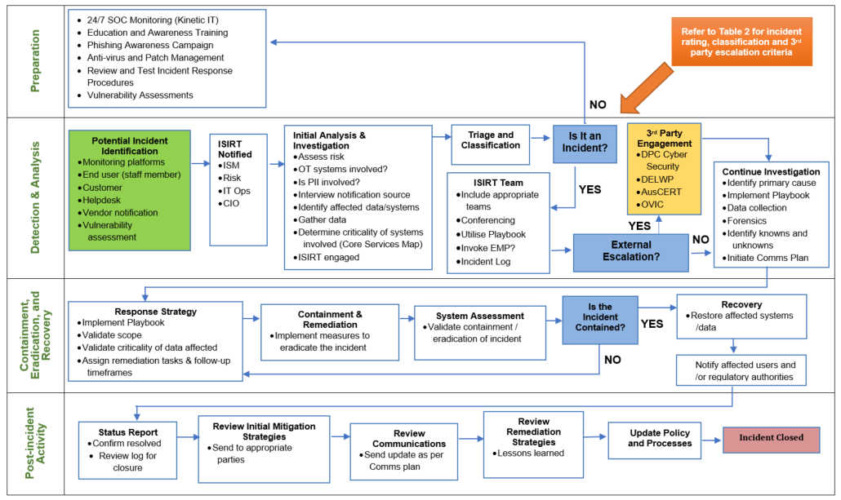

Note that impacts to critical systems on OT networks in the line item of Appendix A equates to a ‘Very High’ cyber security incident severity level.
At present there is no requirement to notify DEECA of Cyber Incidents unless an IMT is triggered. DEECA has requested notification, but it is not mandatory.
Wannon Water is not covered by SOCI or SLACI acts

